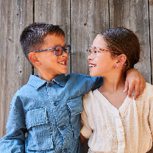 | Making adventures, having fun or creating new things - everything is better together!
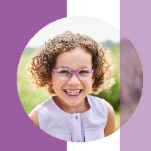 | Purple power! Jetta is wears Noah in light lilac/dark lilac.
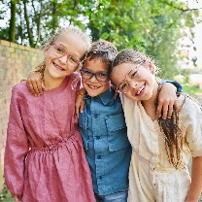 | Joy is amplified when you are together, and worries are reduced when shared!
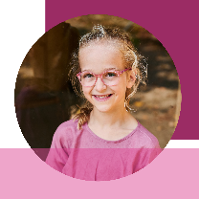 | Our colour combinations are beautifully coordinated! The colours of the front and the temple match seamlessly. Simply better together.
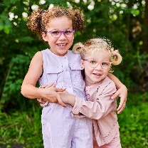 | Sisters! Partners in fun, adventures and sometimes a little mischief. Better together with their Milo & Me glasses!
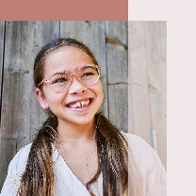 | This spunky and cool frame is our Billie! Lara wears nude/terracotta.
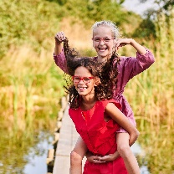 | Kids should feel free to play and romp, run, jump en explore... Together!
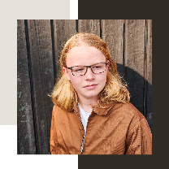 | Always a good combination: Sam wearing Sam! This dark brown/light brown radiates independence and a chill vibe!
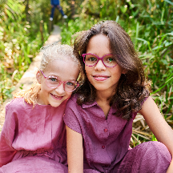 | The more shades of pink, the better! We love soft tones as well as bold ones; together, they look even better.
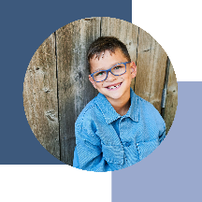 | A bubbly, brave and breezy? A blue will absolutely compliment you! Daan wears Alex in grey blue/light grey blue.

